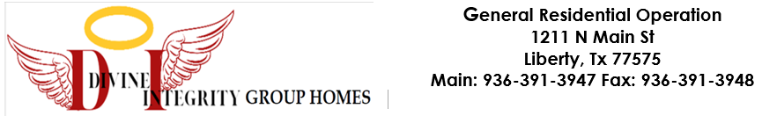

JOB DESCRIPTION
Job Title: Caregiver
Reports To: Executive Director, Licensed Child Care Administrator, Employee Relations & Operations
Department: Residential Operations
Status: Part Time
Location: Divine Integrity Group Home (T3C-Aligned General Residential Operation)

General Job Description
The Caregiver plays a critical role in providing a safe, supportive, and nurturing environment for the children in care. This position is responsible for directly engaging with residents, guiding their daily activities, and promoting their emotional, social, and physical well-being. The Caregiver works collaboratively with other team members to implement individualized treatment plans, enforce rules, regulations, policies, and procedures while creating a positive and enriching living experience for the residents.
The ideal candidate will have a strong commitment to ensuring the safety of residents. Will demonstrate professionalism, reliability, great communication skills and physical endurance as this position is physically demanding. This role requires adherence to HHSC Minimum Standards, DFPS and CPS policies, and T3C Blueprint guidelines.

Essential Duties & Responsibilities
- Provide direct care and supervision to residents during shifts, including mornings, evenings, weekends, or emergencies.
- Assist residents with daily living activities, hygiene, dressing, meals, chores, and recreational participation.
- Monitor and document resident behavior, mood, and interactions, reporting all concerns to the Administrator or treatment team.
- Support therapeutic and behavioral goals as outlined in each resident’s service plan.
- Utilize approved de-escalation techniques and behavior management strategies during crisis or high-stress situations.
- Assist with medication administration and ensure medication is documented and stored in compliance with GRO requirements (if trained and authorized).
- Ensure the living environment is clean, organized, and safe.
- Maintain accurate shift documentation, incident reports, communication logs, and other required forms.
- Communicate effectively with team members, supervisors, and external stakeholders (caseworkers, medical staff, etc.).
- Follow all GRO policies, procedures, and licensing standards, including emergency preparedness, supervision, and staffing ratios

Qualifications
• Must be at least 21 years of age.
• High School Diploma or GED.
• Valid Identification Card or Drivers License
• Successful background check, drug screening, and TB test.
• Physical ability to lift 40 lbs and engage in active supervision.
• Strong communication, problem-solving, and team collaboration skills.
• Emotional maturity and the ability to stay calm under pressure.
• Customer service-oriented with attention to detail and ability to follow instructions.
Key Competencies
• Attention to detail and multi-tasking
• Positive Role Modeling
• Behavioral Support and Guidance
• Reliable and Consistent
• Communication and DocumentationPhysical Requirements
• Ability to lift up to 40 lbs
• Capable of standing for prolonged periods
• Must be able to perform vehicle safety checks, enter/exit vehicles, and assist youth with mobility needs

Acknowledgment & Acceptance

I acknowledge that I have read and understand the responsibilities, qualifications, and requirements outlined above for the position of Driver / Transportation (with PRN Caregiver Duties). I agree to perform the duties in accordance with all applicable standards, regulations, and policies.

Signature: _______________________________________
Printed Name: ____________________________________
Date: ______________________

